**CREATE A WEB APP IN MICROSOFT AZURE**

1. First we go to the website azure.microsoft.com and sign up.

Dashboard->new-> WebApp create a new name.

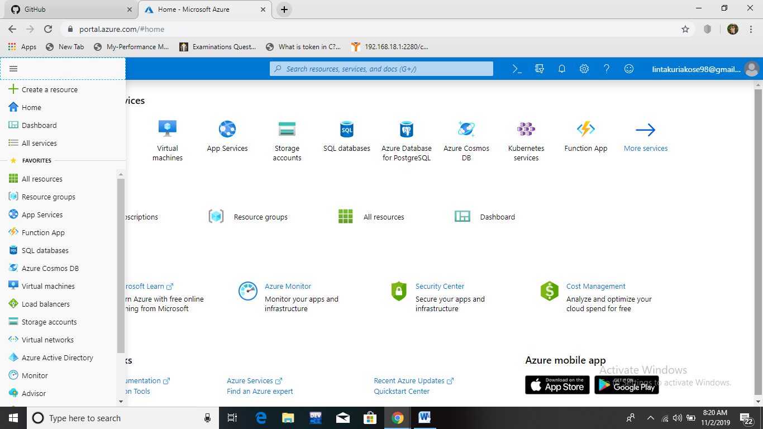

1. Go to azure portal and click **create a resource ->Web+mobile ->WebApp**

~~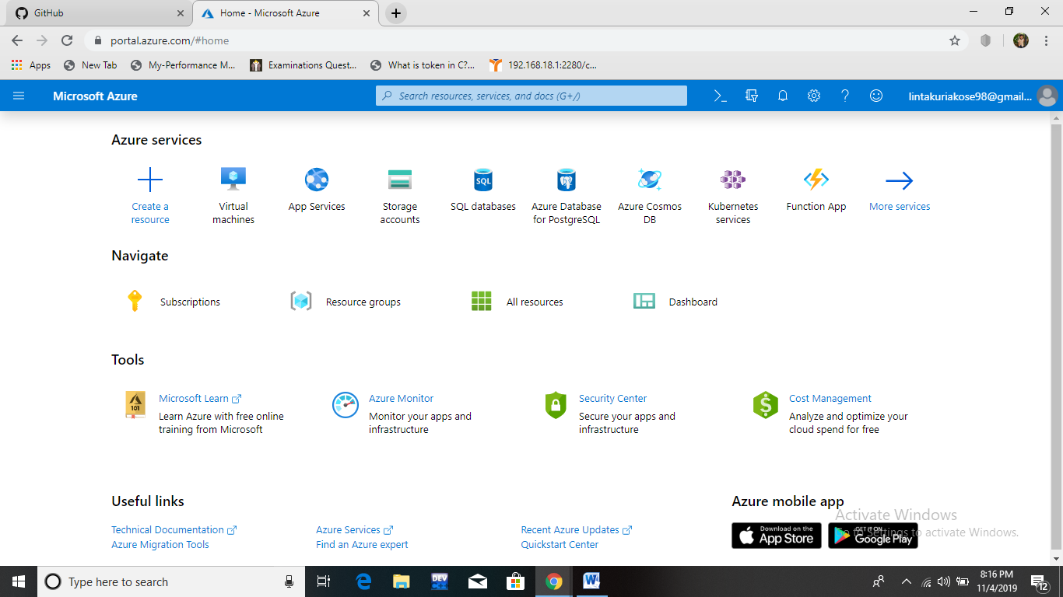~~

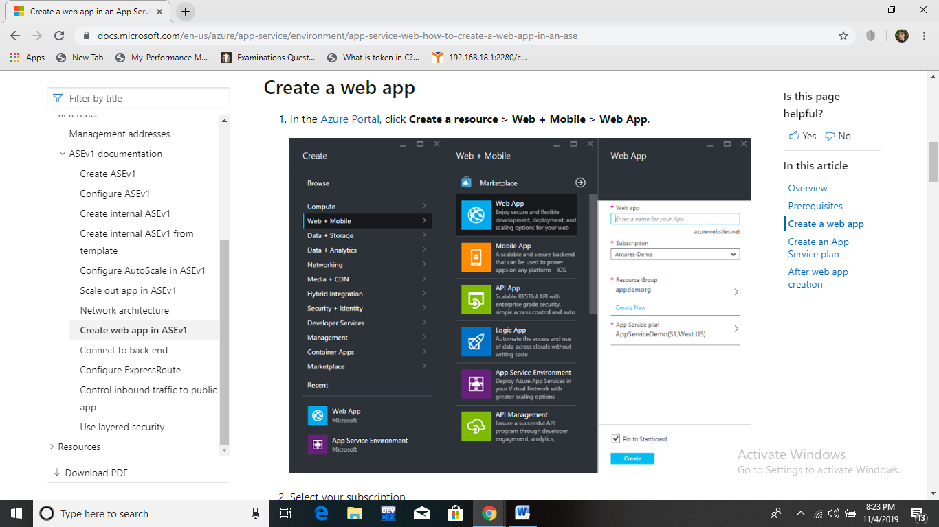

3.Select the subscription

For me it is free trial.

4.Select a resource group otherwise Create a resource group.

5.create service plan and enter the name of WebApp and click create

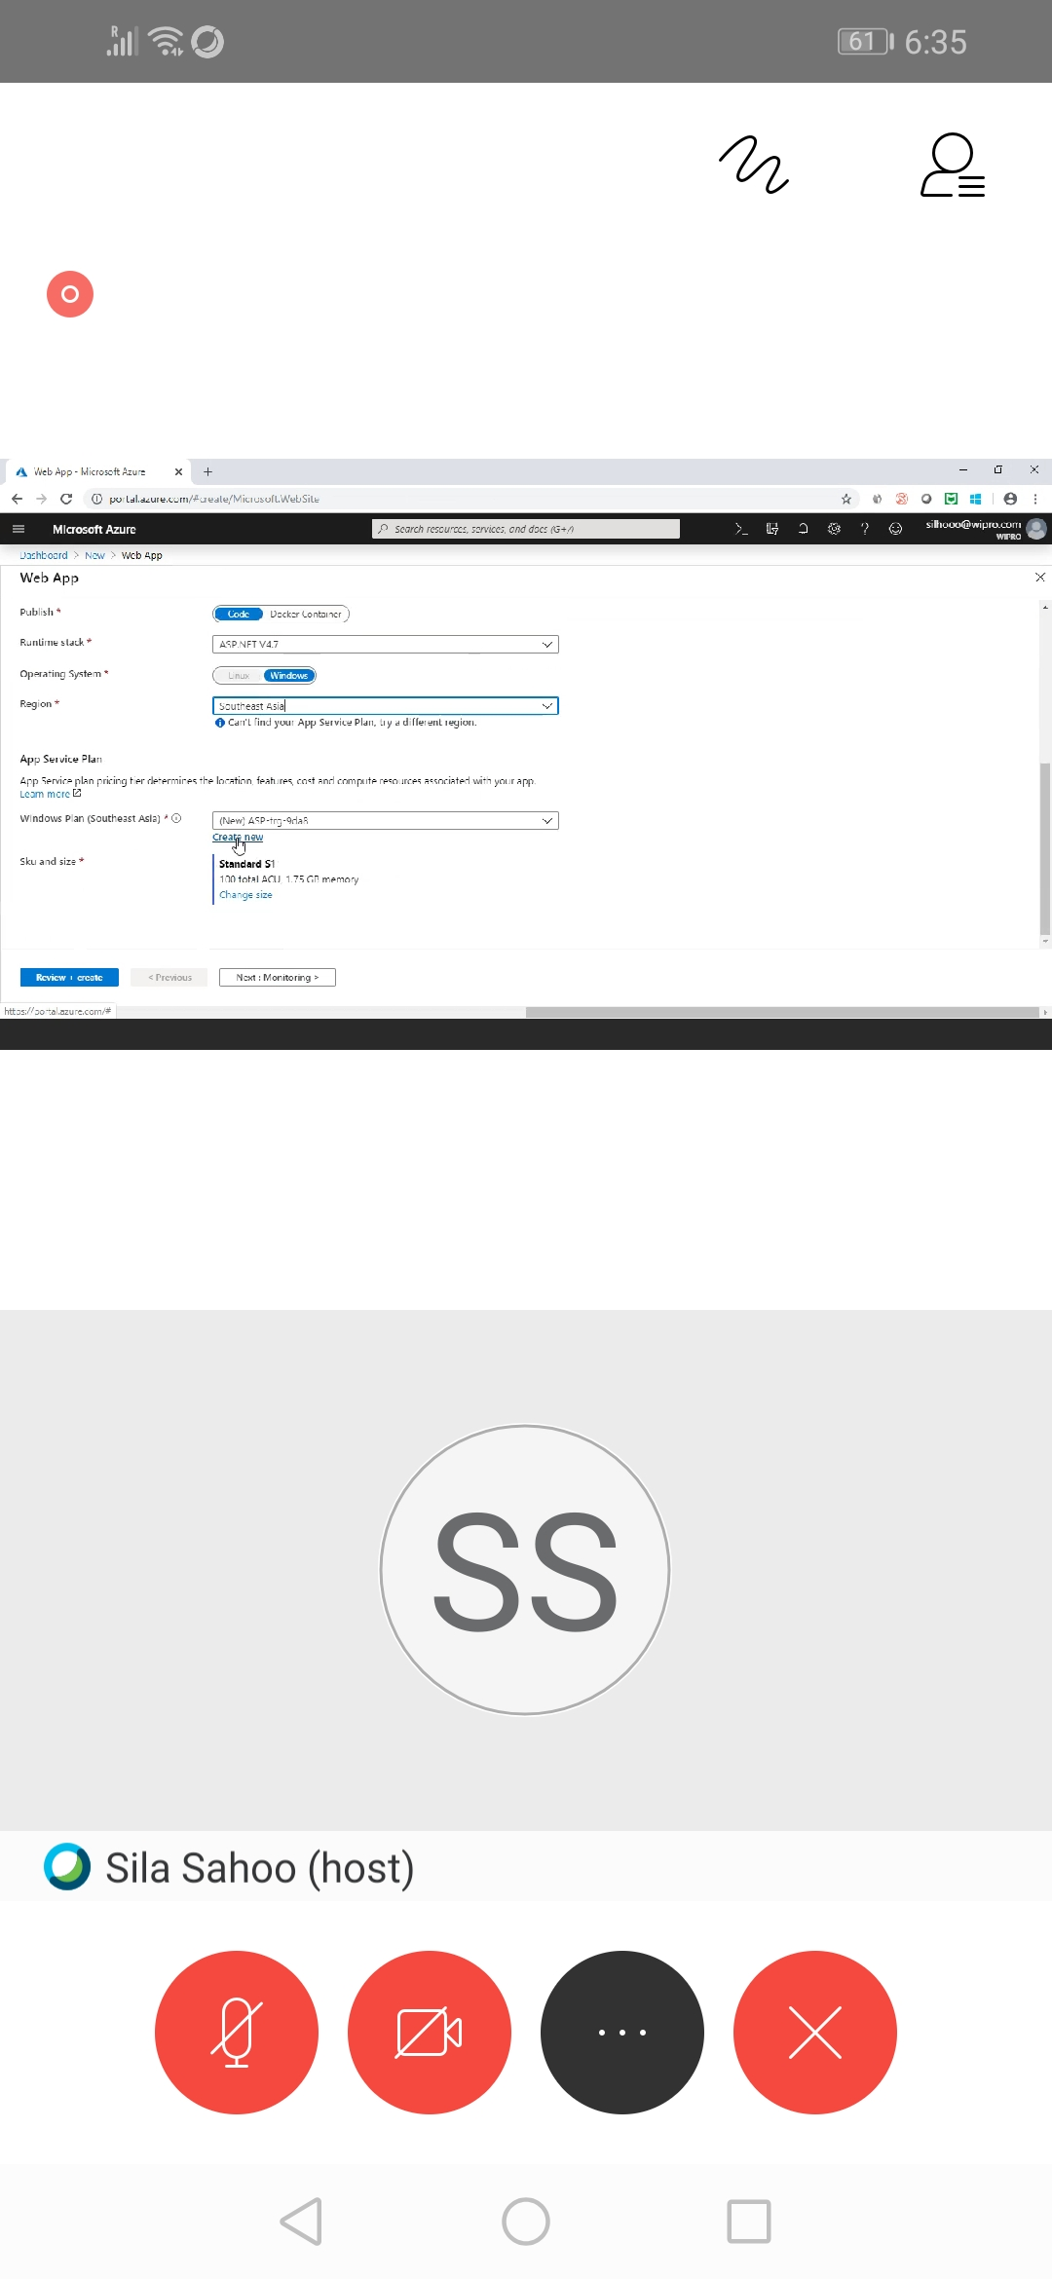

Here WebApp is created successfully.